PerX Project Progress Report

Overview of Project
The PerX project has developed a Pilot service which provides subject resource discovery across a series of repositories of interest to the engineering learning and research communities. This pilot is being used as a test-bed to explore the practical issues that would be encountered when considering the possibility of full scale subject resource discovery services.

Issues being investigated include: the range and availability of actual and potential digital repository sources; exploration of cultural barriers to the use of repositories in the subject community, functionality of software tools; advocacy to encourage participation of repository providers; maintenance issues; interactions with infrastructural shared services; enhancing metadata quality; embedding and reuse of resource discovery services; improving search and browse results presentation; service profiling for particular audiences, and service sustainability.

Grant Statement
We confirm that the project is being conducted under the terms agreed with JISC in the letter of grant of 13th May 2005 and the JISC Terms and Conditions attached to it.

2. Aims and Objectives

Objective: Using the pilot subject-based cross-repository search tool as a testbed, ascertain from a selection of academic end-users in engineering their opinions on the appropriateness of the subject-based approach to resource discovery, and the effectiveness of different versions of the pilot.
This Objective has been partially met, when the first version of the Pilot was used as a testbed. An improved version is currently under development, and once available will be further used as a testbed and evaluated with end-users.

Objective: Monitor, quantify and document the technical and management effort required during the pilot.
This Objective has been partially met. Procedures have been put in place to monitor this effort, and monitoring is proceeding. A report detailing the set-up and maintenance effort expended by the PerX team for the 12 month period between March 2006 and February 2007 will be available in March 2007.

Objective: Investigate and implement automatic methods of harvesting repositories.
This Objective is partially complete. As previously reported, the Project experienced delays due to the delayed availability of the Pilot software. Since then, and the development of the PerX toolkit, methods of implementing automatic harvesting have been investigated, but at the time of writing, nothing has been implemented. ARC and PKP and other options listed at OAI Tools http://www.openarchives.org/tools/tools.html were investigated at the beginning of the project. PKP Harvester Ver 2 has been released since then, and we are currently examining its potential. PerX has also been in touch with OAIster, Celestial and OJAX, but none appear to be using completely automated methods for reharvesting purposes. Experience elsewhere, therefore, confirms that this is not a simple matter, especially when dealing with large repositories or repositories which do not use the OAI validator. Methods to automatically harvest 5 small targets are now being developed, but whether these methods will continue to work in the future is not clear.

Objective: Analyse suitability of JISC shared infrastructural services for use within the pilot, and experiment with the incorporation of a minimum of two.
This Objective has been met. A Shared Services Report is available at: http://www.icbl.hw.ac.uk/perx/sharedservices.htm

Objective:
Consider methods of metadata enhancement, and implement if appropriate
This Objective is partially complete. Some low level augmentation methods have been used. These will be detailed in the forthcoming Augmentation Report.

Objective: Identify a number of potential source repositories, and work with them to understand their needs and encourage their participation.
This Objective is partially complete. Whilst some of this work is complete, some repositories are still being encouraged to participate (M&C, IEEE).

Objective: Add new repositories to the pilot subject-based cross-repository search tool.
This Objective is partially complete.
Several repositories have been added to the Pilot since the last report: ADT, DiVA, Open Video Project, ICE Virtual Library, STINET, JORUM, and Emerald. Work is continuing with others (Oxford Journals, IStructE, OSTI). This work will continue until just before the revised Pilot is to be evaluated by end-users.

Objective: Embed the pilot search tool within a VLE.
This Objective is partially complete. We are hoping that this objective may be completed by April 2007.

Objective: Enable reuse and tailoring of search results by users.
This Objective is partially complete. Several enhancements to the service (Full text indicators, Advanced Search refinements, etc) which were not anticipated in the Project Plan, but which were highlighted as being of benefit through feedback from focus groups and an online questionnaire, are currently being implemented. It is hoped that Post Search Clustering (tailoring of results), and Record Selection, to enable users to select, view, export (reuse) and remove selected records, will be implemented.

Objective: Develop a separate instance of the pilot aimed at a particular group.
This Objective has been met. A separate demo service has been made available:
http://www.engineering.ac.uk/civil/ The Institution of Civil Engineers has used this demo in a survey of selected users, which has provided valuable feedback to PerX.

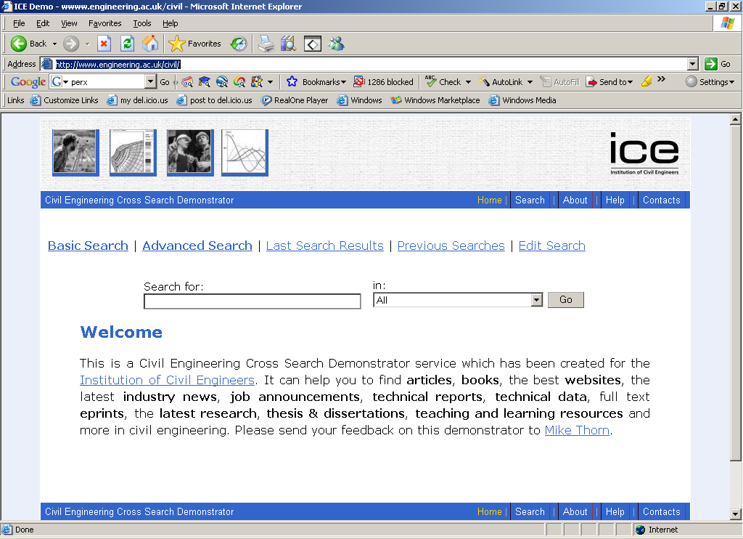

3. Overall Approach
There are no changes to the overall approach outlined in the project plan.

4. Project Outputs

Reports from Focus Groups/interviews with users and questionnaire, detailing end-user opinion on the appropriateness of the subject-based approach to resource discovery, the range of different types of materials available in the pilot cross-search service, and gaps in coverage.
Delivered. User Feedback Report available at: http://www.icbl.hw.ac.uk/perx/userfeedback.htm

Some advocacy work with potential target repositories is ongoing.

Shared service usage scenario within pilot cross-search
Delivered. A Shared Services Report is available at: http://www.icbl.hw.ac.uk/perx/sharedservices.htm

Progress Report, End July 2006.
Delivered. PerX Progress Report available at: http://www.icbl.hw.ac.uk/perx/docs/PerX_FirstAnnualProgressReport.doc

Separate trial instance of the pilot based upon a particular user group’s needs.
Delivered. http://www.engineering.ac.uk/civil/

5. Project Outcomes
More repositories of potential interest to the engineering community have become available (ADT, DiVA, Open Video Project, ICE Virtual Library, STINET, JORUM, Emerald), with more to follow. (Oxford Journals, IStructE, and hopefully also OSTI, M&C, IEEE).

Publicising the various PerX deliverables has increased awareness within the engineering community of the benefits of digital repositories. Material about PerX has continued to appear in external publications (Peter Scott’s Library Blog, various other blogs, Research Information, Ariadne, and Library + Information Update). A poster was presented at the Open Scholarships Conference.

The availability, and increasing use of, the TechXtra service http://www.techxtra.ac.uk , a freely available service and an initiative of Heriot-Watt University, is encouraging practical resource discovery from repositories in engineering, maths and computing. TechXtra was recently recognised by IWR: http://pages.citebite.com/v9r3e8h0lbpn however future funding to allow the continuation of TechXtra beyond June 2007 is uncertain.

Experience of using shared services (IESR) has being gained.

Knowledge about the maintenance effort required for subject-based services is being actively collated.

Knowledge of the particular needs of a specific user group has been gained.

Progress made so far has not changed the project. It has been noted that the amount of effort needed to maintain a potential subject-based service is significant, and larger than originally anticipated.

Our experience continues to show that persuading publishers to adopt standardised interoperable approaches such as OAI-PMH, in addition to their well established means of metadata exchange with the large search engines, is an uphill struggle.

Our experience shows that even where interoperable approaches are taken by publishers (e.g. OAI-PMH), the process of harvesting is often neither simple nor trouble free. See above under Section 2: “Objective: Investigate and implement automatic methods of harvesting repositories.” This is an area which would benefit from further research and development. Celestial, OJAX and PerX may propose some joint work.

Our experience shows that users of cross-search services request a large amount of digital repositories to be cross-searched, especially, but not restricted to commercial sources.

6. Stakeholder Analysis
PerX has been in contact with various producers of content included in the Pilot.

Availability of the deliverables mentioned above has been promoted to some JISC email lists. PerX presented a poster at the JISC Open Scholarships Conference.

PerX has worked with the IESR.

PerX has continued to work with a number of publishers. In particular, the ICE, Emerald and IStructE are aware of the benefits of exposing their data to the Pilot.

Intute has been kept informed about PerX deliverables.

7. Risk Analysis

Hardware.
More hardware problems were experienced, and the PerX servers were switched towards the end of the reporting period. The PerX Technical Officer has been burdened with webmaster duties which were not anticipated in the original Plan (due to the removal of JISC funding for the EEVL webmaster and the subsequent loss of that post).

Software.
The successful development of the PerX toolkit has meant that the set of tasks agreed with ILRT for work on the SPP software is no longer needed.

Content. The Programme Management should note that the continued unavailability of the ePrints UK service, or alternative, for inclusion on the PerX cross-search Pilot, is causing concern. Evaluation of the enhanced pilot without this target will mean that much UK IR content is not included in the tests. The Intute Executive Manager has indicated that we will be sent details of the repository search project timescales.

8. Standards
No change.

9. Technical Development
Changes are detailed above under Risk Analysis: Software. The Perx Administrative Interface (PAIN) has simplified administrative changes to the Pilot.

10. Intellectual Property Rights
N/A

Project Resources

11. Project Partners
The Project has been working closely with representatives of the ICE in the development and testing of a Civil Engineering Cross-Search Demonstration Service.

One partner, GROW, was encouraged to publish in Ariadne:
GROW: Building a High-quality Civil Engineering Learning Object Repository and Portal
Yan Han http://www.ariadne.ac.uk/issue49/yan-han/

12. Project Management
Regular meetings of the Project staff have been held. The Technical Manager has undertaken additional webmaster duties, as detailed above under Risk Analysis: Hardware

13. Programme Support
The PerX Project Officer attended the Open Scholarships Conference.

14. Relationships with other projects activities

PerX has checked the DigiRep wiki, and has added material to it.

14. Budget
See Appendix A.

Detailed Project Planning

15. Workpackages

Task 13. Hold focus groups and interviews with users, and make questionnaire available on website.
Partially completed. Second round of Focus Groups are still to be held.

Task 14. Document user experience and views.
Partially completed. Reports from the first round are available.

Task 15. Produce advocacy materials.
Completed.

Task 16. Work with a range of potential data providers to better understand issues.
Partially completed, and also ongoing.

Task 19. Implement automatic harvesting mechanism for OAI repositories.
Partially Completed.

Task 21. Work with IESR to utilise up to date target information from central registry.
Completed.

Task 22. Investigate appropriate error reporting mechanisms, both to administrators and end-users.
Partially completed.

Task 23. Quantify and document maintenance effort required during the pilot.
Partially completed.

Task 24. Ongoing monitoring of current trends in interoperability standards.
This is ongoing.

Task 25. Addition of new repository sources resulting from advocacy work.
Partially completed, and ongoing.

Task 26. Ongoing monitoring of digital repositories landscape within engineering.
This is ongoing.

Task 27. Pilot enhancement to permit inclusion of repository sources via emergent access methods.
Partially completed.

Task 28. Identify all relevant infrastructural shared services & develop potential usage scenarios.
Completed.

Task 29. Work with ‘mature’ services including Service Registries and Resolver Services.
Completed.

Task 30. Review metadata augmentation techniques, particularly NSDL work.
Completed.

Task 31. Identify and implement safe metadata transformations which are applicable to all collections (e.g. removal of empty metadata elements, double XML encodings, etc.)
Completed.

Task 32. Consider options for metadata augmentation on an individual collection basis.
Partially Completed.

Task 33. Embed basic pilot resource discovery functionality within a VLE at host institution on proof of concept basis.
Partially completed.

Task 34. Add functionality to pilot to enable users to save search results in formats appropriate for reuse. Plus other refinements and enhancements as identified in evaluation of first pilot.
Partially completed.

Task 35. Work with Adiuri.
Cancelled.

Task 36. Consider the needs and typical usage scenarios of various user groups.
Completed.

Task 37. Analysis of the collections offered, collection groupings, terminology and branding styles that would be appropriate for particular user groups.
Completed.

Task 38. Investigate the potential of using filtering techniques.
Cancelled.

Task 39. Develop instance of profiled service for one particular group.
Completed.

Objectives for the next reporting period:

Use the enhanced pilot subject-based cross-repository search tool as a testbed with a second group of users, and document findings.

Monitor, quantify and document the technical and management effort required during the pilot. Complete this Objective

Investigate and implement automatic methods of harvesting repositories.
Complete this Objective

Consider methods of metadata enhancement, and implement if appropriate.
Complete this Objective

Identify a number of potential source repositories, and work with them to understand their needs and encourage their participation.
Complete this Objective

Add new repositories to the pilot subject-based cross-repository search tool.
Complete this Objective

Embed the pilot search tool within a VLE.
Complete this Objective

Enable reuse and tailoring of search results by users.
Complete this Objective

16. Evaluation Plan

The shared service usage scenarios were found by the IESR to be helpful to their future planning process.

Evaluation objectives for the next reporting period include:
Seeking feedback from Focus Groups on the enhanced Pilot, including metadata enhancements; Seeking peer review of sustainability models.

17. Quality Assurance Plan

PerX will hope to utilise SRU in the next reporting period.

18. Dissemination Plan

The RDN (now Intute) Executive Manager has been kept informed about progress and outputs.

Material about PerX has continued to appear in external publications (Peter Scott’s Library Blog, various other blogs, Research Information, Ariadne, and Library + Information Update). A poster was presented at the Open Scholarships Conference.

The findings of the Focus Group and questionnaire were made available on the PerX website, and announced in relevant lists. Repository producers were made aware of the findings.

Availability of Project Reports has been announced in relevant lists.

During the next reporting period, the objectives include announcing the availability of the PerX Setup & Maintenance Issues report, the availability of the Implementation of metadata augmentation functionality report, the findings of the Focus Groups, and the availability of the Progress Report.

As funding for PerX finishes in May 2007, and staff are due to take on other duties from this date, attendance at the DRP Manchester event may be problematic.

The PerX Project has few messages for actual practitioners within universities and colleges - PerX’s messages are directed more to potential service developers, and potential funders of potential services.

Two key messages to those would be:
a) To be successful, subject-based digital repository cross-search services must take account of the real information needs of their target communities. In the case of the community relevant to PerX (technology subjects), this means that a cross-search service must search across numerous different digital repositories of various kinds. As well as content, the design/functionality of the cross-search service is very important.
b) Harvesting of digital repositories via OAI-PMH is often problematic. More work needs to be done to develop solutions in this area, perhaps involving Celestial, OJAX and PerX.

19. Exit/Sustainability Plan

Objectives in the next reporting period include analysing findings of the sustainability models to identify whether it is possible to continue the cross-service as a supported service; arrange for PerX Reports to be archived in appropriate JISC records management system; arrange for PerX website to be archived on Project server, secure maintenance of PerX server after May 2007.

Appendixes

Appendix A. Project Budget

Indicate Reporting Period | YR 2 Budget | YR 2 Spend
 |  | 6 months to 30th Nov 2006
Staff | 33,687 | 15,399
Travel & Subsistence | 1,000 | 398.53
Equipment (items over £10k)
Dissemination activities
Evaluation activities
Other
Focus Groups/Workshops | 1,000 | 400
Partner expenses | 2,600 | 1,000
Training | 500 | 190
Office Costs | 2,554 | 2,554
Total from JISC | 41,341 | 19,941

