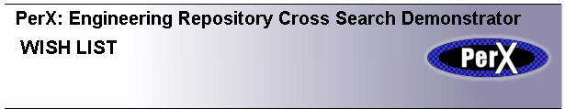

- Five minutes to List the top 3 features YOU would like to see developed in
the PerX Pilot Service

My No1 Feature ………………………………………………………………

Reason?

My No2 Feature ………………………………………………………………

Reason?

My No3 Feature ………………………………………………………………

Reason?

